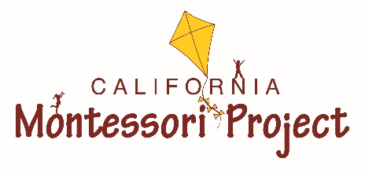
Shingle Springs Campus
School Supply List: 2022-2023
4/5/6 Classes: Magnolia Class Edition
You can help your child be prepared for the first day of school by bringing in the supplies listed below.
Find a good bargain?! - We will be counting on your donations to outfit your child’s classroom with consumable supplies. Plentiful supplies ensure that our students have a productive and self-directed learning environment. Pick up an extra item or two to stock the classroom supply cupboards for when our community supplies need to be replenished.
4th/5th/6th:
- 6 Composition Books: Wide-Ruled
- Three-Prong Plastic Poly Folder: Black
- 1.5-inch Binder (white, heavy duty)
- 1 Boxes of Color Pencils (Crayola preferred)
- 1 Pair of Headphones (no wireless)
- 1 Lunch Box (no logos) with Reusable Food Storage Containers
- 1 Reusable Water Bottle (non-disposable)
4th
- 2 boxes of Ticonderoga HB Pencils
- Heavy Duty Sheet Protectors (minimum 50)
- Glue Sticks
- Pink Erasers
- 2 Reams of Wide Ruled Lined paper
- Colored paper variety pack
5th:
- 2 boxes of Ticonderoga HB Pencils
- Heavy Duty Sheet Protectors (minimum 50)
- Glue Sticks
- Pink Erasers
- 2 Reams of Wide Ruled Lined paper
- White Cardstock
6th:
- 2 boxes of Ticonderoga HB Pencils
- Heavy Duty Sheet Protectors (minimum 50)
- Glue Sticks
- Pink Erasers
- 2 Reams of Wide Ruled Lined paper
- 1 Ream of Printer Paper

Magnolia Classroom Wish List
We find that our students enjoy contributing to their classroom environment! If you and your child enjoy back-to-school shopping, you may want to purchase a small donation for the classroom. Any items purchased can be used as a donation for Parent Participation Hours.
The following items are some suggestions:

Card Stock (black, white or colored) Graph paper Washable Tempera Paints
Kleenex Sanitizing wipes Acrylic paints
Band-Aids Laminating Sheets Water Color Paper
Elmer’s White Glue Scotch Tape Refills Scrapbook paper
Scissors Swiffer Dusters

Gift certificates to Amazon, Teacher Supply Stores, JoAnn’s, or Michaels, etc. are always welcomed.

Personal Supplies (Please label with child’s name):
Classroom Community Supplies (Please don’t label):

